**Project Planning Phase**

**Product Backlog, Sprint Schedule, and Estimation (4 Marks)**

Use the below template to create product backlog and sprint schedule

|  |  |  |  |  |  |
| --- | --- | --- | --- | --- | --- |
| **Sprint** | **Functional**  **Requirement (Epic)** | **User Story**  **Number** | **User Story / Task** | **Story Points** | **Priority** |
| Sprint-1 | Registration (Mobile user) | USN-1 | As a user, I can register for the application by entering my email, password, and confirming my password. | 1 | Low |
| Sprint-1 | Login (Mobile user) | USN-2 | As a user, I can log into the application by entering email & password | 3 | High |
| Sprint-2 | Dashboard (Mobile user) | USN-3 | By entering correct password, I could access the dashboard. | 13 | Medium |
| Sprint-3 | Alert message (Mobile user) | USN-4 | As a user, I can get alert messages regarding smoke and temperature parameters. | 13 | High |
| Sprint-4 | Data storage (Mobile user) | USN-5 | As a user, I will able to store parameter values. | 2 | High |
| Sprint-4 | Checking (Mobile & web user) | USN-6 | As a user I can Test the system performance, for an emergency case, it is deployed and I can use the system 24/7. | 8 | High |
| Sprint-1 | Login (web user) | USN-7 | As a user, I can log into the application by entering email & password | 13 | High |
| Sprint-1 | Dashboard (web  user) | USN-8 | I could access the dashboard. | 3 | Medium |
| Sprint-3 | Alert message (web user) | USN-9 | As a user, I can get alert messages regarding smoke and temperature parameters. | 5 | High |
| Sprint-4 | Data Storage message (web user) | USN-10 | As a user, I will able to store parameter values. | 2 | High |
| Sprint-4 | Checking (Mobile & web user) | USN-11 | As a user, I can check whether the system correctly detects the fire and gas, and does it alerts the user, also whether the fire or smoke has been put down or not. | 8 | High |

**Project Tracker, Velocity & Burndown Chart: (4 Marks)**

|  |  |  |  |  |  |  |
| --- | --- | --- | --- | --- | --- | --- |
| **Sprint** | **Total Story Points** | **Duration** | **Sprint Start Date** | **Sprint End Date (Planned)** | **Story Points**  **Completed (as on**  **Planned End Date)** | **Sprint Release Date (Actual)** |
| Sprint-1 | 20 | 6 Days | 24 Oct 2022 | 29 Oct 2022 | 20 | 29 Oct 2022 |
| Sprint-2 | 20 | 6 Days | 31 Oct 2022 | 05 Nov 2022 | 20 |  |
| Sprint-3 | 20 | 6 Days | 07 Nov 2022 | 12 Nov 2022 | 20 |  |
| Sprint-4 | 20 | 6 Days | 14 Nov 2022 | 19 Nov 2022 | 20 |  |

**Velocity:**

Imagine we have a 10-day sprint duration, and the velocity of the team is 20 (points per sprint). Let’s calculate the team’s average velocity (AV) per iteration unit (story points per day)

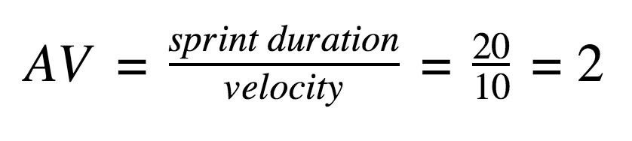

**Burndown Chart:**

A burn down chart is a graphical representation of work left to do versus time. It is often used in agile [software development m](https://www.visual-paradigm.com/scrum/what-is-agile-software-development/)ethodologies such as [Scrum.](https://www.visual-paradigm.com/scrum/scrum-in-3-minutes/) However, burn down charts can be applied to any project containing measurable progress over time.

[**https://www.visual-paradigm.com/scrum/scrum-burndown-chart/**](https://www.visual-paradigm.com/scrum/scrum-burndown-chart/) [**https://www.atlassian.com/agile/tutorials/burndown-charts**](https://www.atlassian.com/agile/tutorials/burndown-charts)



0



2



4



6



8



10



12



14



day 1



day 2



day 3



day 4



day 5



**BURNDOWN CHART**

**Reference:**

[**https://www.atlassian.com/agile/projec**](https://www.atlassian.com/agile/project)[**t-management**](https://www.atlassian.com/agile/project-management) [**https://www.atlassian.com/agile/tutorials/how-to-do-scrum-with-jira-software**](https://www.atlassian.com/agile/tutorials/how-to-do-scrum-with-jira-software) [**https://www.atlassian.com/agile/tutorials/epics**](https://www.atlassian.com/agile/tutorials/epics) [**https://www.atlassian.com/agile/tutorials/sprints**](https://www.atlassian.com/agile/tutorials/sprints) [**https://www.atlassian.com/agile/project-management/estimation**](https://www.atlassian.com/agile/project-management/estimation) [**https://www.atlassian.com/agile/tutorials/burndown-charts**](https://www.atlassian.com/agile/tutorials/burndown-charts)